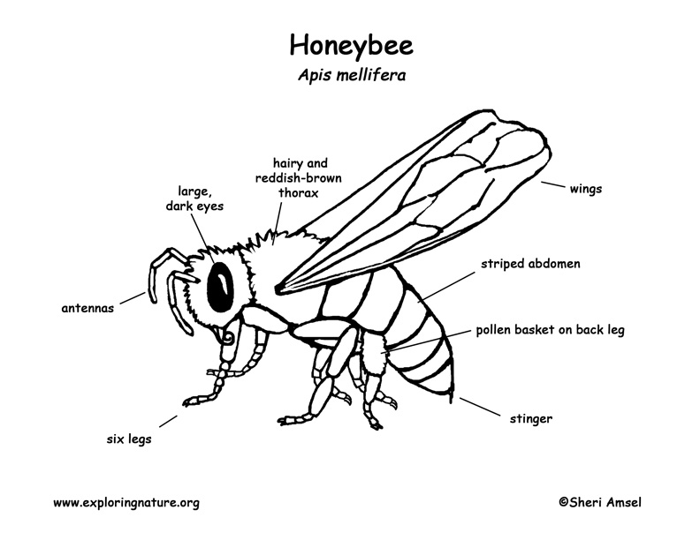

**Directions:** Print this picture of a honeybee, and color its different parts. A real bee has black and yellow coloring, but you can choose any color you want for this activity.