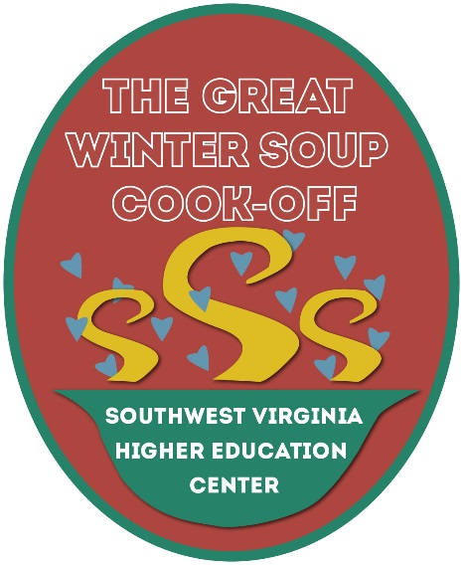
Southwest Virginia Higher Ed Center
Presents
The 5th Great Winter Soup Cook-Off
Introducing “Dueling Ladles”
February 10, 2018

What: A soul-warming community soup competition.

Purpose: Fundraiser to support Southwest Virginia Higher Education Center’s educational programs, enriching the lives of those in our community.

Date and Time: Saturday, February 10, 11am-3pm Awards ceremony 2:30 pm.
Related event: Dueling Ladles, a live iron chef faceoff 10 am (separate ticket needed)

Place: Southwest Virginia Higher Education Center Grand Hall, One Partnership Circle, Abingdon, VA 24212.

Competitors: $20.00 registration per soup plus business door prize for Professional Category;
$20.00 registration per soup for Amateur Category (individual and/or group); www.swcenter.edu/soupcookoff.

Judging: A panel of culinary experts will taste and rate the soups in a blind tasting. The soups will be rated on a scale from 1-5 using 4 judging criteria (aroma, taste, appearance, texture).

Event Host: Chris McIntosh from Channel 11, Daytime Tri Cities, WJHL

Awards: 1st, 2nd, 3rd Cash Prizes will be given in Professional and Amateur categories, including joint category, People’s Choice and Rooted in Appalachia Awards. Professional group 1st prize winner will also have a traveling trophy to display at business for one year. Special category awards will be presented by some sponsors. There will also be a Showmanship Award for the best booth decorations.

Special Mini-Classes: Scheduled cooking demonstrations and informative cooking classes.

Admission: $10.00 Cook off 11am-3pm Free for children under 5. Door prize eligibility with adult ticket purchase and People’s Choice vote
20.00 Cook Off/Dueling Ladle Package 10 am (includes admission to cook-off & reserved seating for Dueling Ladles)

Tickets available online at www.swcenter.edu/soupcookoff.

Vendors: Limited to culinary related products and services. $60.00 for booth space includes a covered table and two chairs and electricity.

Perks: Educational culinary classes; door prizes, culinary vendors, great media coverage and a full tummy; lots of fun!

Contact: Higher Education Center at 276.619.4300; swebb@swcenter.edu; jferreira@swcenter.edu

